ARC · Initiative A · Design Doc
Exploitation-Request Sandbox — Design & Requirements
A network-contained agent that pulls source from S3, analyses it, and runs code it writes — with no other access
Field | Value
Status | DRAFT — for review
Author | Iswarya V.
Reviewers | — (platform / security / cloud)
Version · Date | 1.0 · 2026-10-06
Classification | Internal
Scope | Production design; the POC is Phase 1 (network containment)
Related | InitiativeA-Fargate-sandbox-arch (diagram) · InitiativeA-compute-options-ec2-vs-ecs (alternatives)

1 · The need, and POC scope

1.1 Production end-state (the final need)
In production, ARC runs a governed, exploitation-request-driven code-analysis sandbox service. Exploitation requests arrive; a provisioning service stages the source into S3; and for each request an isolated agent run (harness = Google ADK with custom changes; model via Amazon Bedrock, Claude family) analyses the source and runs code it writes — under full governance (per-action authorization, Rules of Engagement, human-in-the-loop where required) — returning results to downstream consumers. It runs many concurrent isolated runs at scale, with audit, retention and resilience.
The non-negotiable invariant at every scale is network containment: each run can reach only its authorised inputs and outputs (its source in S3, the model, its results) and nothing else — no internet, no other AWS, no lateral movement. Claude Code is NOT used on this path. OpenAI models are a possible alternative family — an open question (§8), not committed. Any model route stays in-perimeter (no public API over the internet).

1.2 POC scope — Phase 1 (what we prove first)
The POC proves the hardest, most load-bearing part of that need: network containment of a single run, with source pre-placed in S3 and the model via Bedrock. Success = containment (the §9 exit-test), not analysis quality.
In the POC: one run at a time, started by a launcher, with the full containment control set (§5.1–5.9). Not built in the POC — but specified as production requirements in §5.10: the provisioning service, the governance service, HITL, concurrency/scale, request intake, and multi-model. The POC is built forward-compatible (FC1–FC6) so those add on without rework.

2 · Goals and non-goals

Goals
- Prove an agent can pull source from S3, analyse it, and write + run code with zero other network or AWS access.
- Deployable in our own AWS account, entirely in-perimeter (no internet, Bedrock in-account).
- Forward-compatible with the future exploitation-request provisioning flow (§7) at no rework cost.
- A repeatable containment exit-test (§9) that a reviewer can run to accept the POC.

Non-goals for the POC (these ARE production requirements — see §5.10)
- Per-action governance service, Rules-of-Engagement engine, human-in-the-loop — separate initiatives.
- Attacking a live running target (this POC analyses source, it does not exploit a deployed system).
- Building the Source-Provisioning Service itself (future — only its seam is designed now).
- A console/UI, multi-tenant scale, and analysis-quality tuning.

3 · Architecture
A launcher (ECS RunTask / Step Functions) starts one ephemeral task per request with the source bucket+prefix. The task runs the agent harness, pulls source via the S3 gateway endpoint, calls the model via the in-account Bedrock interface endpoint, pulls its image via ECR endpoints, writes logs/results — and can reach nothing else. The task is wiped on exit.
Containment principle. Deny-by-default by ABSENCE, not filtering: the task runs in private subnets with no internet gateway and no NAT, so there is no route to the internet. The only exit is a small set of scoped VPC endpoints. Three independent walls must all agree before any byte leaves: (a) routing — no internet path; (b) security group — egress only to the endpoints; (c) IAM + endpoint policy — only the specific bucket and model.
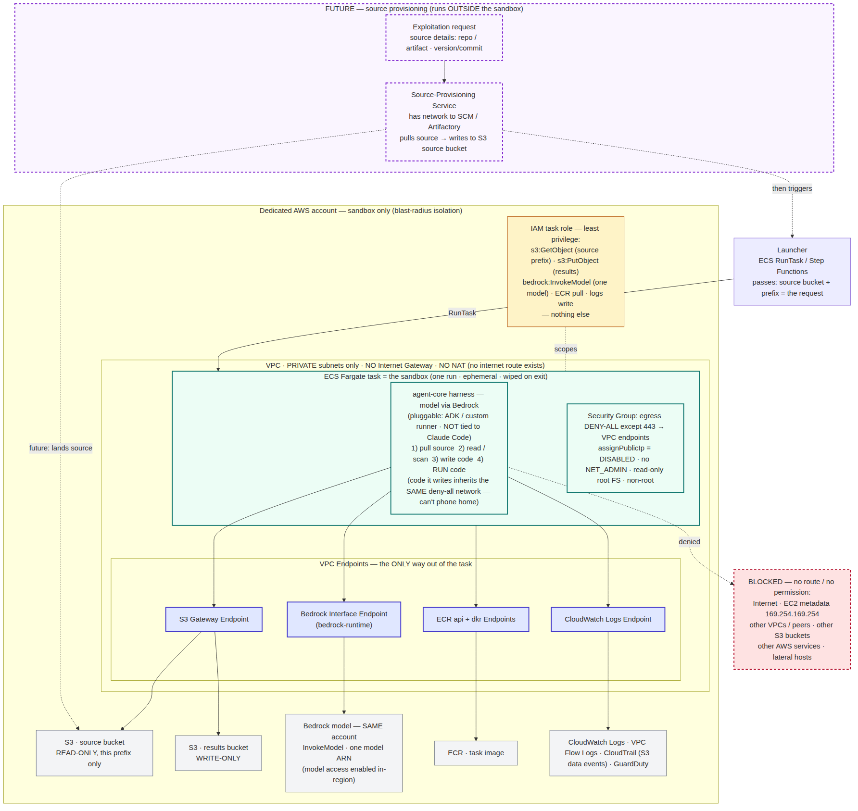
Figure 1 — the sandbox reaches only S3, Bedrock, ECR and Logs via VPC endpoints; everything else has no route. Dashed purple = future source-provisioning (§7).
Growing to production. The same contained task is the unit of execution in production. What production adds around it (§5.10) is request intake, the source-provisioning service, the governance service, autoscaling to many concurrent runs, and evidence/result delivery. The task's containment — this diagram — does not change; production is this picture replicated and wrapped, not redesigned.

4 · Alternatives considered
Summarised here; each locked choice is recorded as an ADR in Appendix A.
Decision | Options | Choice (ADR)
Compute | EC2 single-run vs ECS Fargate | Fargate — no host to patch, per-task microVM, auto-cleanup (ADR-001)
Model access | Bedrock (Claude) — POC · OpenAI models — possible later | Bedrock in-account via interface endpoint for the POC; OpenAI left as an OPEN QUESTION (§8), not decided (ADR-002)
Containment | Egress proxy/filter vs no-route-by-absence | Absence (no IGW/NAT) as the primary wall, policy as backstop (ADR-003)
Harness | Claude Code vs Google ADK | Google ADK with custom changes — Claude Code not used (ADR-004)
Source hand-off | Direct SCM pull into task vs S3 seam | S3 bucket as the seam; provisioning stays outside the task (ADR-005)

5 · Requirements
MUST / SHOULD = priority. IDs are stable for traceability (§9). Phase: the containment set (§5.1–5.8) applies in BOTH the POC and production — it is the invariant; §5.9 (FC) is built in the POC to enable production; §5.10 (PR) is production-only, not built in the POC.

5.1 Infrastructure, account & VPC isolation
ID | Requirement | AWS service / mechanism | Priority
INF1 | Compute: run each sandbox as one ephemeral task per request (AWS-managed Firecracker microVM isolation) | Amazon ECS on Fargate | MUST
INF2 | Orchestration/launcher: start one task per request with run parameters | ECS RunTask / Step Functions | MUST
INF3 | Private registry for the agent container image | Amazon ECR (private) | MUST
N1 | Dedicated sandbox account (or dedicated VPC) separate from production | AWS account / Organizations OU | MUST
N2 | Private subnets only — NO Internet Gateway, NO NAT | VPC route tables | MUST
N3 | Task gets NO public IP | assignPublicIp=DISABLED | MUST

5.2 Network egress — the funnel
ID | Requirement | AWS mechanism | Priority
N4 | SG egress DENY-ALL except 443 to the VPC endpoints / S3 prefix list | Task SG egress rules | MUST
N5 | Subnet NACL deny-all except endpoint ENIs (static backstop) | Network ACLs | SHOULD
N6 | No VPC peering / Transit Gateway routes to any other network | Route tables (absence) | MUST
N7 | Code the agent writes and runs inherits the same deny-all network | Single task network namespace | MUST

5.3 VPC endpoints (only way out) + endpoint policies
ID | Requirement | AWS mechanism | Priority
E1 | S3 gateway endpoint; policy limited to source bucket (read) + results bucket (write) | S3 Gateway endpoint + policy | MUST
E2 | In-account Bedrock interface endpoint; policy = InvokeModel on the one model | Interface endpoint (bedrock-runtime) | MUST
E3 | Image pull via ECR api + dkr endpoints (+ S3 gateway for layers) | ecr.api, ecr.dkr | MUST
E4 | Logs via CloudWatch Logs interface endpoint | logs endpoint | MUST
E5 | No other interface endpoints present | Endpoint inventory review | MUST
E6 | Bedrock model access enabled for the model in this account + region | Bedrock console · model access | MUST
Model family note. This POC uses Bedrock (Claude family) via E2. OpenAI models are a possible alternative but are an open question (§8), not decided — if ever adopted they would need their own in-perimeter route under the same egress rules (N4), never the public internet, keeping N2 intact. No OpenAI endpoint is required for this POC.

5.4 IAM least privilege
ID | Requirement | AWS mechanism | Priority
I1 | Task role: s3:GetObject (source prefix) + s3:PutObject (results prefix), ARN-scoped | IAM task role | MUST
I2 | Task role: bedrock:InvokeModel on one in-account model ARN (no bedrock:*) | IAM task role | MUST
I3 | Execution role: only ECR pull + logs write | IAM execution role | MUST
I4 | No s3:* , no account-wide perms, no iam:* / ec2:* | Access Analyzer review | MUST
I5 | Buckets enforce TLS + only the task role | S3 bucket policy | SHOULD

5.5 Metadata & credential protection
ID | Requirement | AWS mechanism | Priority
M1 | Verify EC2 IMDS 169.254.169.254 is NOT reachable from the task; block link-local metadata as defense-in-depth. (On Fargate IMDS isn't exposed — this is belt-and-suspenders; the real cred path is M2) | egress deny / verify | SHOULD
M2 | Task-role creds reach the task ONLY via the ECS task credential path 169.254.170.2; protect it | Fargate default | MUST
M3 | No long-lived AWS keys in the image or env | Image + task-def review | MUST

5.6 Task / container hardening
ID | Requirement | AWS mechanism | Priority
C1 | Ephemeral: one run per task; storage discarded on stop | ECS RunTask lifecycle | MUST
C2 | Read-only root FS + scratch volume for write/run | readonlyRootFilesystem | SHOULD
C3 | Non-root; no privileged; drop caps incl. NET_ADMIN | task def linuxParameters | MUST
C4 | CPU/mem/storage limits + task-level timeout | task sizing + timeout | MUST
C5 | Agent image from private ECR (scanned), pinned by digest | ECR + digest pin | SHOULD

5.7 Observability & audit
ID | Requirement | AWS mechanism | Priority
O1 | VPC Flow Logs — every allowed + denied flow | VPC Flow Logs | MUST
O2 | CloudTrail S3 data events on source + results buckets | CloudTrail data events | MUST
O3 | Agent stdout/stderr + transcript to CloudWatch Logs | awslogs driver | MUST
O4 | Alarm on any denied/blocked egress attempt | Flow Log metric filter; GuardDuty | SHOULD

5.8 Lifecycle & data
ID | Requirement | AWS mechanism | Priority
L1 | Launcher starts task with run params (source bucket+prefix, run id) | RunTask / Step Functions | MUST
L2 | Hard wall-clock timeout; force-stop past it (Fargate has no fixed max — hours OK; on-demand, not Spot) | launcher timeout | MUST
L3 | On-demand kill path for an in-flight task | StopTask + runbook | SHOULD
D1 | Source read-only; results write-only; separate buckets | S3 + bucket policy | MUST
D2 | KMS-encrypt source/results/logs; task role scoped to the key | SSE-KMS | SHOULD
D3 | Results are the only thing that leaves; nothing written back to source | bucket policy | MUST

5.9 Forward-compatibility (build into the POC NOW so the future design in §7 drops in without rework)
ID | Requirement | How enforced | Priority
FC1 | Source location is a RUNTIME PARAMETER (bucket+prefix), never hardcoded | task overrides via launcher | MUST
FC2 | Source laid out per-run now: s3://<source-bucket>/<run-id>/… ; sandbox reads only its prefix | S3 key convention + IAM (I1) | MUST
FC3 | Results keyed by run_id: s3://<results-bucket>/<run-id>/… | S3 key convention | MUST
FC4 | run_id is THE correlation key across source prefix, results prefix, logs | minted by launcher | MUST
FC5 | Launcher invocable programmatically / event-driven | RunTask API / EventBridge target | SHOULD
FC6 | Nothing in the sandbox assumes WHO placed the source — it only reads S3 | design rule (the S3 seam) | MUST

5.10 Production requirements (the end-state — specified now, NOT built in the POC)
These capture how the sandbox looks in production. They are specified now so the POC is built toward them (via the FC set); none are built in the POC.
ID | Production requirement | Component / mechanism | Priority
PR1 | Concurrency: many isolated requests run in parallel — one Fargate task (microVM) each, no shared state between runs | ECS RunTask fan-out / service | MUST
PR2 | Request intake: accept exploitation requests via a queue/event bus (dedup, ordering, backpressure) — not manual launch | EventBridge / Kafka / SQS | MUST
PR3 | Source provisioning: a service stages source into the S3 seam and triggers runs (detail: FR1–FR7, §7) | Source-Provisioning Service (outside the task) | MUST
PR4 | Governance integration: each run's actions pass per-action authorization + RoE + HITL; the sandbox exposes the hooks | Governance service (separate initiative) · ADK callbacks | MUST
PR5 | Autoscaling + limits: scale concurrency to demand; per-tenant concurrency caps; global kill-switch + budget caps | ECS autoscaling + control plane | MUST
PR6 | Resilience: multi-AZ; idempotent retries; graceful task-retirement handling; durable results | multi-AZ subnets + retry design | SHOULD
PR7 | Evidence & retention: results/findings persisted with retention / WORM + long-term audit logs | evidence store + log retention | MUST
PR8 | Result delivery: publish results downstream with request→run→result correlation | event/topic + run_id / request_id | SHOULD

6 · Cross-cutting concerns
- Security. Containment by absence (N2) + deny-all egress (N4) + least-privilege IAM (I1–I4) + metadata block (M1). The agent and any code it runs are confined to the task's deny-all network.
- Data / privacy. Source read-only, results write-only, separate buckets (D1/D3); KMS everywhere (D2); results are the only egress artefact.
- Cost. Pay-per-task-second; analysis is I/O-bound (waiting on model), so modest CPU suffices. No idle infrastructure (ephemeral tasks).
- Observability / audit. Flow Logs + CloudTrail data events + CloudWatch transcript (O1–O3); alarm on escape attempts (O4) — a defensible audit trail for a regulated setting.
- Operability. No host to patch (Fargate); image scanned + digest-pinned (C5); hard timeout + kill path (L2/L3).
- Compliance. Requirement IDs + the §9 exit-test give traceability auditors can check; dedicated account bounds blast radius (N1).

7 · Future design — exploitation-request-driven source provisioning
An exploitation request (source details — repo/artifact coords, version/commit) arrives; a Source-Provisioning Service (OUTSIDE the sandbox, own network to SCM/Artifactory, own scoped perms) pulls source → writes s3://<source-bucket>/<run-id>/ → signals 'source ready' → launcher starts the run. S3 is the seam; the sandbox is unchanged.
ID | Future requirement | Component / mechanism | Priority
FR1 | Define request contract {request_id, source:{type,coords,version}, target_metadata, roe_ref?} | JSON Schema (contract-first) | MUST
FR2 | Provisioning service resolves request → writes source to the per-run prefix | new service, outside sandbox | MUST
FR3 | Service: SCM/Artifactory network + write-only to source prefix; no results read; not in the task | own IAM role + SG | MUST
FR4 | 'Source ready' signal triggers the launcher | S3 event / EventBridge / API → FC5 | MUST
FR5 | Idempotency: one request_id → one bundle → one run | dedup on request_id | SHOULD
FR6 | Provenance: request_id + source version → run_id linkage | run metadata + CloudTrail | SHOULD
FR7 | Producer swap (S3 → Artifactory/SCM) normalised into the same S3 seam | provisioning adapter | SHOULD
FR1–FR7 land cleanly only because the POC satisfies FC1–FC6 (§5.9). Build the FC set now and the future service is additive, not a rewrite.

8 · Risks & open questions
Item | Detail / resolution needed
Results destination | Assumed a separate write-only S3 results bucket — confirm with stakeholders.
Dedicated account | Assumed a dedicated sandbox account (or VPC) — confirm it is provisioned.
Bedrock model access | Must be enabled for the specific model in-region (E6) or InvokeModel fails even with correct IAM.
OpenAI models (OPEN) | Whether to also support OpenAI models, and if so how to reach them in-perimeter (Azure OpenAI in-account? internal gateway?). Out of scope for this POC — Bedrock is the POC route.
Fargate limits | Verify current vCPU/mem/ephemeral ceilings + Spot behaviour against AWS docs; on-demand only for long runs.
TLS-inspected egress | Endpoint policies gate destination + API, not payload; acceptable for this POC (no live target).

9 · Acceptance — containment exit-test (with traceability)
The POC is accepted when all of the following pass. Each test cites the requirement IDs it verifies.
Test | Verifies
From inside the task, reaching the internet, a second S3 bucket, another AWS service, and 169.254.169.254 all FAIL | N2·N4·N6·E5·I4·M1
Pulling the authorized source prefix and calling the one model SUCCEED | E1·E2·E6·I1·I2·FC2
VPC Flow Logs show the denied attempts and the alarm fires | O1·O4
Task stops and ephemeral storage is gone after the run; results only in the results bucket | C1·D1·D3
Results and logs are keyed by run_id end-to-end | FC3·FC4

Appendix A · Architecture Decision Records

ADR-001 — Compute = Amazon ECS on Fargate
Status: Accepted
Context: The sandbox needs per-run isolation with minimal ops. Options were EC2 single-run (full control, you patch the host) and Fargate (AWS-managed, per-task Firecracker microVM).
Decision: Run each sandbox as one ephemeral Fargate task.
Consequences: No host to patch; cleaner metadata story (block IMDS); auto-cleanup; fast start. Trade-off: resource ceilings and no nested virtualisation — acceptable for source analysis. Hours-long runs are fine (no fixed max; on-demand, not Spot).

ADR-002 — Model access = Bedrock (Claude) for the POC; OpenAI open
Status: Accepted (POC) · OpenAI OPEN
Context: The agent must call a model without opening internet egress (which would break containment). Bedrock (Claude family) is available in-account. OpenAI models are a possible alternative but the route is not yet decided.
Decision: Use Bedrock in-account via the bedrock-runtime interface endpoint for this POC (Claude family), IAM scoped to one model ARN. OpenAI is left as an OPEN QUESTION (§8) — not decided; if ever adopted it must be reached by its own in-perimeter route under the same egress rules.
Consequences: Keeps 'no internet route' intact. No OpenAI endpoint is built for this POC. Note: in-account does not make Bedrock private by itself — the interface endpoint is still required, and model access must be enabled in-region (E6).

ADR-003 — Containment by absence, not by filter
Status: Accepted
Context: An agent may try to reach the internet, metadata, or other networks. A proxy/filter can be bypassed or mis-scoped.
Decision: Make containment structural: private subnets with no IGW and no NAT, so no internet route exists; SG + endpoint/IAM policy are backstops.
Consequences: Strongest, easiest-to-audit control (there is simply nowhere to go). Requires VPC endpoints for every legitimate destination.

ADR-004 — Harness = Google ADK with custom changes
Status: Accepted
Context: The craft team uses Claude Code, but the exploit-request path should not use it.
Decision: Use Google ADK with custom changes as the agent harness; Claude Code is not used on the exploit-request path.
Consequences: The containment design stays harness-agnostic, so the requirements hold regardless. ADK's callbacks (before/after model + tool) are a natural fit for later governance hooks.

ADR-005 — S3 is the source/results seam
Status: Accepted
Context: Today source is placed in S3 by hand; in future a service will provision it. The sandbox should not care who places it.
Decision: Make the S3 source bucket the contract (seam); the sandbox only reads S3. Provisioning stays outside the task (§7).
Consequences: The future provisioning service is additive, not a rewrite (FC1–FC6). Producer can later shift from S3 to SCM/Artifactory behind the same seam.

